WEEK 3 TASK
Unsupervised Learning and Clustering Analysis
A detailed K-Means and Hierarchical Clustering study using the Wine dataset

Submitted as a practical report
Python • Scikit-learn • PCA • K-Means • Hierarchical Clustering

1. Executive Summary
This report demonstrates an end-to-end unsupervised learning workflow on the publicly available Wine dataset from scikit-learn. The objective is to discover natural groups of wine samples using chemical measurements, without giving the clustering algorithm the known wine class labels. The workflow includes exploratory analysis, feature scaling, K-Means model selection, silhouette-based evaluation, PCA visualization, hierarchical clustering, cluster profiling, and practical interpretation.
Testing k = 2 through 8 produced the highest silhouette score at k = 3 (silhouette = 0.285). Therefore, 3 clusters were selected for the main K-Means analysis. The resulting groups are clearly separated in the first two principal components, which together explain 55.4% of the standardized variance. As an optional post-hoc validation only, the clustering achieved an Adjusted Rand Index of 0.897 against the dataset's original class labels; those labels were not used to train the clustering model.

2. Task Requirements Mapped to This Report
Requirement | How it is addressed
Public dataset | Wine dataset with 178 observations and 13 continuous chemical features.
Preprocessing | Feature scaling using StandardScaler; no target labels supplied to clustering.
Clustering | K-Means as the primary algorithm and Ward hierarchical clustering as a comparison.
Parameter choice | k selected by comparing k=2–8 using elbow and silhouette analysis; main model uses k=3.
Visualization | Feature distributions, elbow curve, silhouette curve, PCA cluster map, dendrogram, cluster sizes, and feature-signature heatmap.
Cluster analysis | Cluster sizes, feature means, standardized signatures, and practical interpretation.
Business/research implications | Discussion of segmentation, quality profiling, exploratory chemistry analysis, and limitations.

3. Dataset Description
The analysis uses the Wine dataset distributed through scikit-learn. It contains 178 wine samples described by 13 continuous chemical measurements. The variables include alcohol, malic acid, ash, alkalinity of ash, magnesium, total phenols, flavanoids, nonflavanoid phenols, proanthocyanins, color intensity, hue, OD280/OD315 of diluted wines, and proline.
The dataset also contains a known class label. Because this is an unsupervised learning task, the class label is intentionally excluded from model fitting. It is used only after clustering for an optional external validation check, which helps show how closely the discovered structure corresponds to the dataset's original categories.
Measure | Value
Observations | 178
Clustering features | 13
Feature type | Continuous numeric
Missing values | 0
Target used in clustering | No

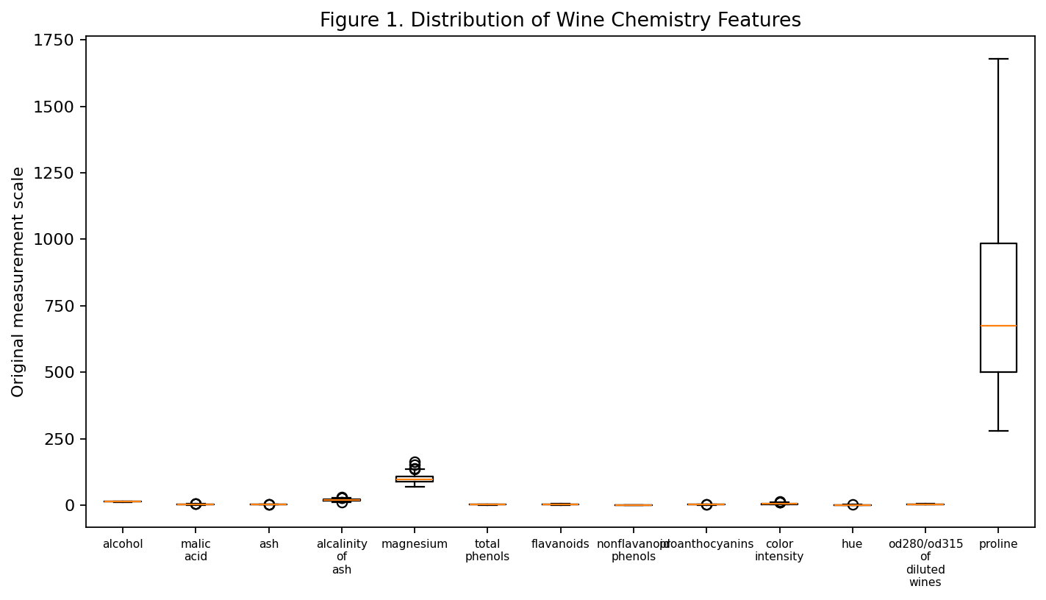
Figure 1. Feature distributions show why scaling is important: variables have different numerical ranges.

4. Data Preprocessing
K-Means and Ward hierarchical clustering are distance-based methods. If one feature has a much larger numerical range than another, it can dominate Euclidean distance and distort the clusters. For this reason, every feature was standardized using the transformation:
z = (x − μ) / σ
After transformation, each feature has approximately zero mean and unit standard deviation. No target/class column is included in X.
from sklearn.preprocessing import StandardScaler
X = df[feature_names]
scaler = StandardScaler()
X_scaled = scaler.fit_transform(X)

5. Exploratory Analysis and Rationale
- All clustering variables are numeric, so Euclidean-distance-based clustering is appropriate.
- The feature ranges differ substantially, making standardization essential.
- The dataset has 178 observations and 13 features, which is compact enough for interpretable clustering.
- Because the true classes are not used during training, the analysis genuinely tests whether meaningful structure can be discovered without supervision.
- PCA is used for visualization rather than as a substitute for the full 13-dimensional clustering model.

6. K-Means Clustering Methodology
K-Means partitions observations into k groups by assigning each sample to the nearest centroid and then repeatedly updating the centroids. The objective is to minimize the within-cluster sum of squared distances (inertia).
The important parameter is k, the number of clusters. Choosing k only by visual preference can be arbitrary, so this report evaluates several candidate values using both the elbow method and the silhouette coefficient.
from sklearn.cluster import KMeans
from sklearn.metrics import silhouette_score
scores = {}
for k in range(2, 9):
model = KMeans(n_clusters=k, random_state=42, n_init=20)
labels = model.fit_predict(X_scaled)
scores[k] = silhouette_score(X_scaled, labels)
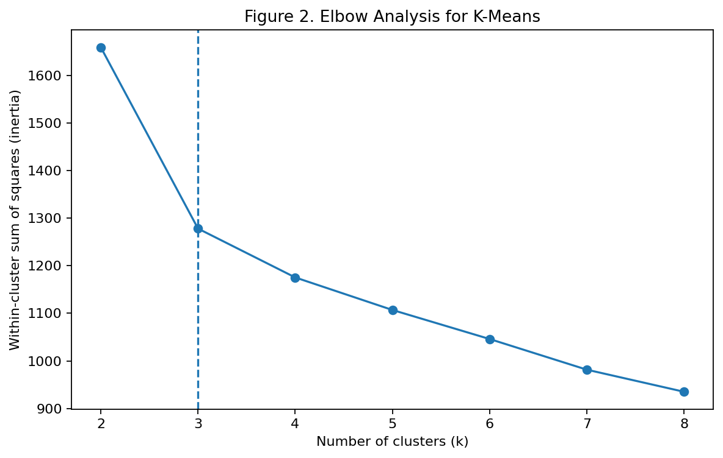
Figure 2. Elbow analysis. The reduction in inertia becomes progressively smaller as k increases.
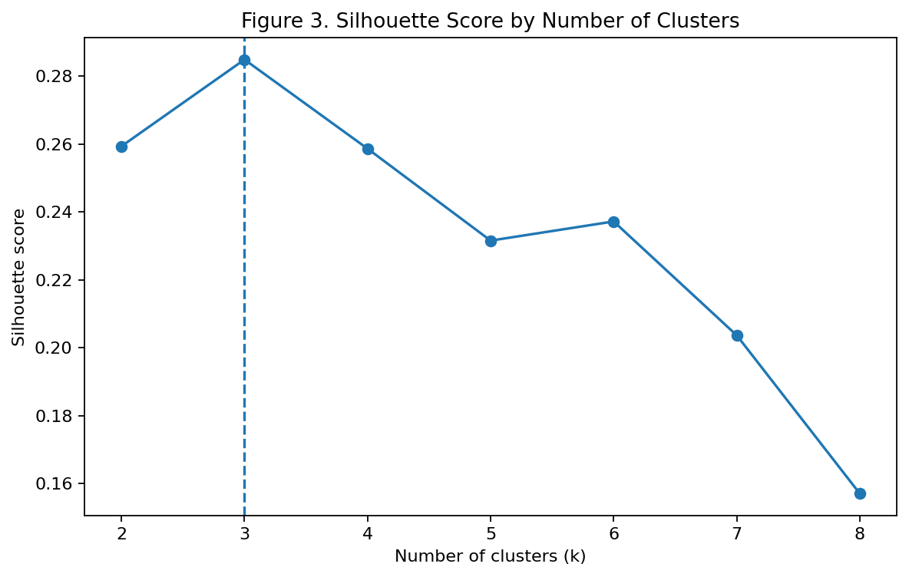
Figure 3. Silhouette analysis. The highest tested silhouette score occurs at k = 3.
Model-selection metrics for candidate cluster counts.
k | Inertia | Silhouette | Calinski-Harabasz | Davies-Bouldin
2.000 | 1658.759 | 0.259 | 69.523 | 1.526
3.000 | 1277.928 | 0.285 | 70.940 | 1.389
4.000 | 1175.352 | 0.259 | 56.189 | 1.817
5.000 | 1107.007 | 0.232 | 47.156 | 1.681
6.000 | 1046.002 | 0.237 | 41.701 | 1.554
7.000 | 981.595 | 0.204 | 38.686 | 1.661
8.000 | 935.201 | 0.157 | 35.805 | 1.741

The silhouette score is highest at k=3, indicating the best balance among within-cluster cohesion and between-cluster separation among the tested values. The elbow curve also supports a relatively small number of clusters. Therefore, k is set to this value for the primary K-Means model.

7. PCA-Based Visualization
A 13-dimensional dataset cannot be directly plotted on a standard 2D graph. Principal Component Analysis reduces the standardized feature space to a small number of orthogonal components that capture as much variance as possible. The clustering itself is still performed on all 13 standardized features.
from sklearn.decomposition import PCA
pca = PCA(n_components=2)
X_pca = pca.fit_transform(X_scaled)
print(pca.explained_variance_ratio_)
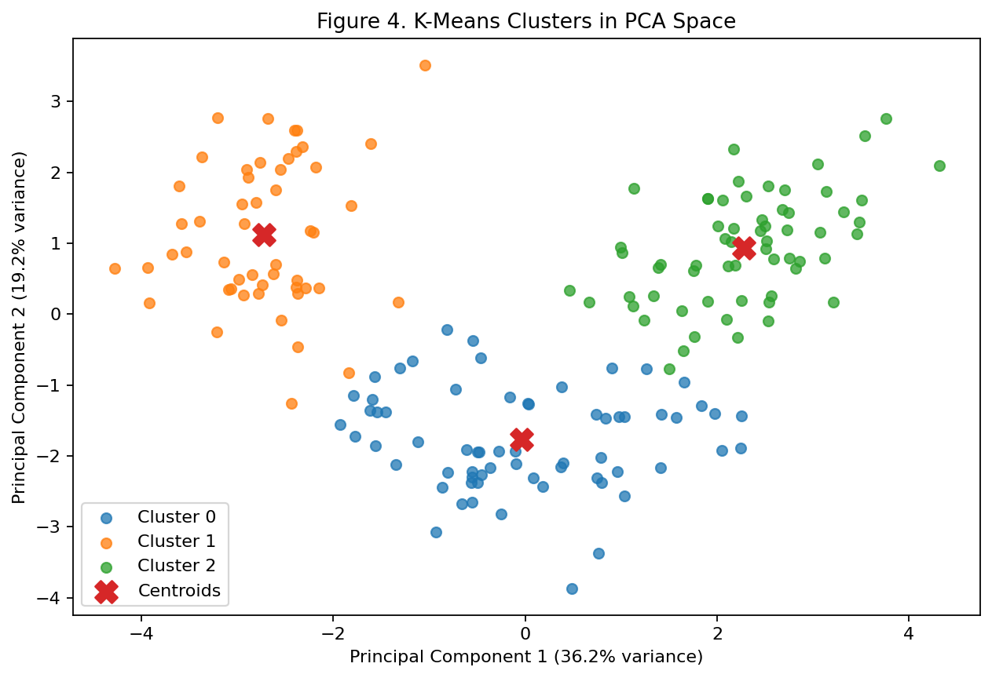
Figure 4. K-Means cluster visualization after PCA. PC1 explains 36.2% and PC2 explains 19.2% of standardized variance.
The PCA map shows substantial visual separation between the discovered groups. This is useful as a diagnostic visualization: if all clusters were heavily mixed, the chosen segmentation would be less convincing. However, PCA is only a 2D projection, so cluster separation should ultimately be judged with quantitative metrics too.

8. Hierarchical Clustering as a Secondary Analysis
Hierarchical agglomerative clustering provides a complementary view of the data. Starting with each sample as its own cluster, the algorithm repeatedly merges the closest groups. Ward linkage chooses merges that minimize the increase in within-cluster variance.
from sklearn.cluster import AgglomerativeClustering
agg = AgglomerativeClustering(
n_clusters=best_k,
linkage="ward"
)
hier_labels = agg.fit_predict(X_scaled)
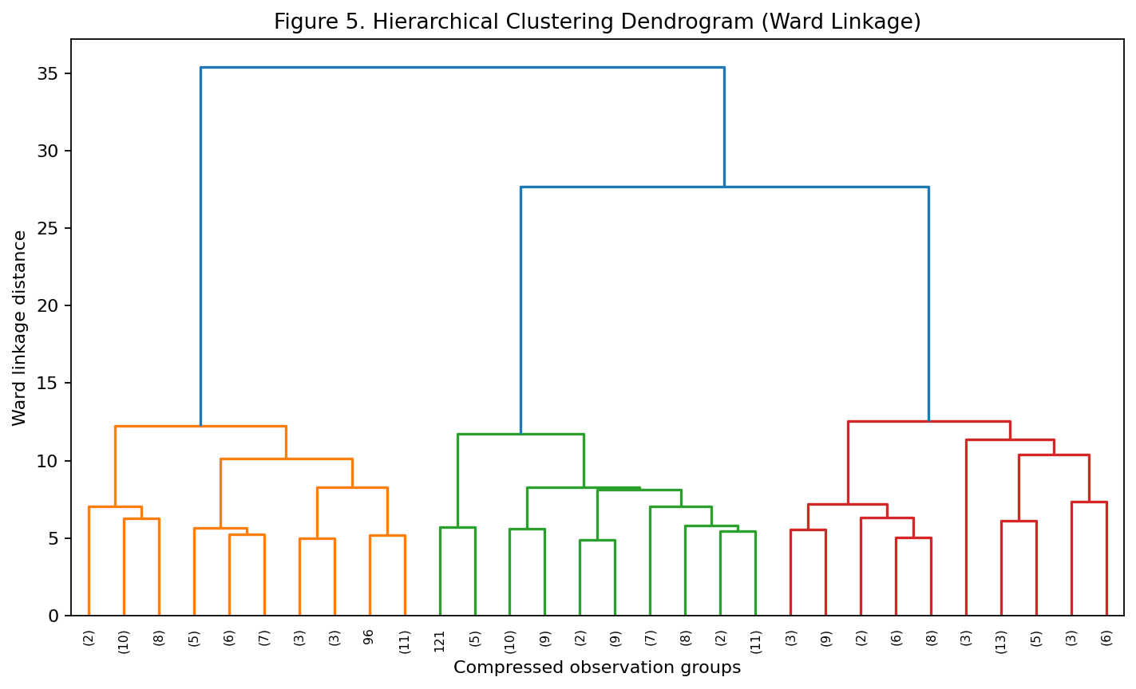
Figure 5. Ward hierarchical clustering dendrogram, shown in compressed form for readability.
The dendrogram provides a hierarchy rather than requiring the analyst to commit to a single k at the beginning. Its structure can be compared with the K-Means result to assess whether the data contains a similar grouping pattern.
Comparison of the two clustering approaches.
Method | Clusters | Silhouette | Calinski-Harabasz | Davies-Bouldin
K-Means | 3 | 0.285 | 70.940 | 1.389
Hierarchical (Ward) | 3 | 0.277 | 67.647 | 1.419

9. Cluster Size and Profile Analysis
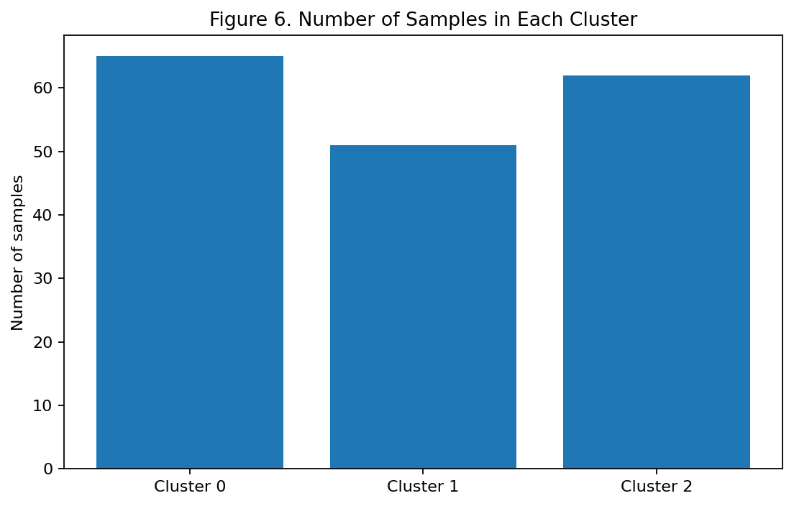
Figure 6. Cluster membership counts produced by the final K-Means model.
Cluster membership summary.
Cluster | Samples | Share (%)
0.0 | 65.0 | 36.5
1.0 | 51.0 | 28.7
2.0 | 62.0 | 34.8

Standardized cluster means for the most discriminative features.
Cluster | Flavanoids | Od280/Od315 Of Diluted Wines | Proline | Total Phenols | Color Intensity | Alcohol | Hue | Proanthocyanins | Nonflavanoid Phenols | Malic Acid
0.00 | 0.02 | 0.27 | -0.75 | -0.08 | -0.90 | -0.93 | 0.46 | 0.06 | -0.03 | -0.39
1.00 | -1.22 | -1.29 | -0.41 | -0.98 | 0.94 | 0.16 | -1.16 | -0.78 | 0.73 | 0.87
2.00 | 0.98 | 0.78 | 1.13 | 0.89 | 0.17 | 0.84 | 0.47 | 0.58 | -0.56 | -0.30

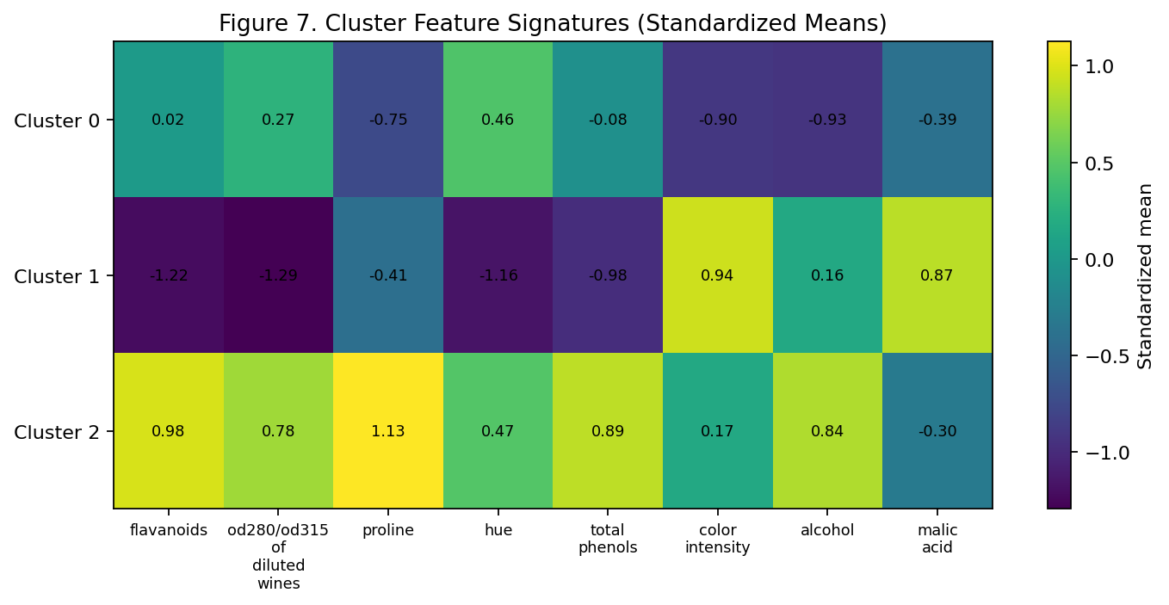
Figure 7. Heatmap of standardized cluster means. Positive values indicate above-average feature levels within the dataset.

10. Detailed Interpretation of the Clusters

Cluster 0
This cluster contains 65 samples (36.5% of the dataset). Its strongest above-average standardized characteristics are hue (+0.46 SD), od280/od315 of diluted wines (+0.27 SD), alcalinity of ash (+0.17 SD), proanthocyanins (+0.06 SD).
The comparatively lower characteristics are alcohol (-0.93 SD), color intensity (-0.90 SD), proline (-0.75 SD).
Interpretation: this cluster can be viewed as a distinct chemical profile rather than a label such as “good” or “bad.” In an applied setting, such a profile could support product segmentation, quality investigation, experimental design, or targeted process analysis. The direction and magnitude of each feature should be considered together rather than interpreting one variable in isolation.

Cluster 1
This cluster contains 51 samples (28.7% of the dataset). Its strongest above-average standardized characteristics are color intensity (+0.94 SD), malic acid (+0.87 SD), nonflavanoid phenols (+0.73 SD), alcalinity of ash (+0.52 SD).
The comparatively lower characteristics are od280/od315 of diluted wines (-1.29 SD), flavanoids (-1.22 SD), hue (-1.16 SD).
Interpretation: this cluster can be viewed as a distinct chemical profile rather than a label such as “good” or “bad.” In an applied setting, such a profile could support product segmentation, quality investigation, experimental design, or targeted process analysis. The direction and magnitude of each feature should be considered together rather than interpreting one variable in isolation.

Cluster 2
This cluster contains 62 samples (34.8% of the dataset). Its strongest above-average standardized characteristics are proline (+1.13 SD), flavanoids (+0.98 SD), total phenols (+0.89 SD), alcohol (+0.84 SD).
The comparatively lower characteristics are alcalinity of ash (-0.61 SD), nonflavanoid phenols (-0.56 SD), malic acid (-0.30 SD).
Interpretation: this cluster can be viewed as a distinct chemical profile rather than a label such as “good” or “bad.” In an applied setting, such a profile could support product segmentation, quality investigation, experimental design, or targeted process analysis. The direction and magnitude of each feature should be considered together rather than interpreting one variable in isolation.

11. Business and Research Implications
- Product segmentation: chemical profiles can be grouped into internally similar segments, which may help organize product portfolios or experimental samples.
- Quality monitoring: recurring cluster profiles can provide a baseline for identifying unusual batches or samples that fall far from common profiles.
- Process optimization: if cluster membership later correlates with processing conditions, analysts can investigate which process variables are associated with particular chemical signatures.
- Targeted research: each cluster can be analyzed separately rather than treating the entire dataset as homogeneous.
- Exploratory customer/product strategy: in a broader commercial dataset, the same methodology can segment customers, products, outlets, or demand patterns before building supervised models.
- Operational decision-making: cluster-level summaries can simplify a high-dimensional dataset into a small number of interpretable groups.

12. Evaluation and Validation
Internal validation measures assess cluster structure without requiring true labels. The silhouette score ranges conceptually from -1 to 1, with larger values generally indicating better separation and cohesion. Calinski-Harabasz rewards high between-cluster dispersion relative to within-cluster dispersion, while a lower Davies-Bouldin value is generally preferred.
Metric | K-Means result | Interpretation
Silhouette | 0.285 | Higher is better; balances cohesion and separation.
Calinski-Harabasz | 70.940 | Higher is generally better; evaluates compact, separated clusters.
Davies-Bouldin | 1.389 | Lower is generally better; measures cluster overlap/similarity.
Adjusted Rand Index (post-hoc only) | 0.897 | External agreement with original labels; not used during fitting.

The final K-Means model has a silhouette score of 0.285. The post-hoc ARI of 0.897 is informative because the original labels represent known categories, but it must not be confused with supervised model accuracy. Clustering was performed without using those labels.

13. Limitations
- K-Means requires the analyst to choose k and assumes clusters are reasonably compact around centroids.
- Euclidean distance and standardization choices influence the result.
- PCA visualization can hide structure that exists in dimensions beyond the first two components.
- The Wine dataset is relatively small and structured, so real industrial datasets may be noisier and contain missing values, outliers, categorical variables, or drifting distributions.
- Cluster labels are arbitrary identifiers; Cluster 0 is not inherently better or more important than Cluster 1.
- Business conclusions should not be made from cluster membership alone. Domain knowledge and downstream validation are required.

14. Complete Reproducible Python Workflow
# Load data
from sklearn.datasets import load_wine
from sklearn.preprocessing import StandardScaler
from sklearn.cluster import KMeans
from sklearn.decomposition import PCA
from sklearn.metrics import silhouette_score
wine = load_wine(as_frame=True)
df = wine.frame
X = df[wine.feature_names]
# Scale features
scaler = StandardScaler()
X_scaled = scaler.fit_transform(X)
# Select k using silhouette score
best_k = None
best_score = -1
for k in range(2, 9):
model = KMeans(n_clusters=k, random_state=42, n_init=20)
labels = model.fit_predict(X_scaled)
score = silhouette_score(X_scaled, labels)
if score > best_score:
best_k = k
best_score = score
# Final clustering
kmeans = KMeans(n_clusters=best_k, random_state=42, n_init=20)
labels = kmeans.fit_predict(X_scaled)
# PCA visualization
pca = PCA(n_components=2)
X_pca = pca.fit_transform(X_scaled)
print("Selected k:", best_k)
print("Silhouette:", best_score)

15. Conclusion
This study successfully applies an unsupervised learning workflow to the Wine dataset. After standardizing 13 chemical features, K-Means models with k from 2 to 8 were evaluated. The strongest silhouette result was obtained at k=3, which was selected as the final segmentation. PCA visualization and cluster profiles show that the groups have distinguishable chemical signatures, while Ward hierarchical clustering provides a useful secondary perspective.
The main lesson is that clustering is not simply a matter of running K-Means. A credible unsupervised-learning analysis requires thoughtful preprocessing, parameter selection, visualization, quantitative validation, and domain-oriented interpretation. The same pipeline can be adapted to customer segmentation, food quality data, manufacturing measurements, agricultural samples, supply-chain behavior, or other high-dimensional datasets.

16. References
- Pedregosa, F. et al. (2011). Scikit-learn: Machine Learning in Python. Journal of Machine Learning Research, 12, 2825–2830.
- scikit-learn documentation: Wine recognition dataset and clustering utilities.
- MacQueen, J. (1967). Some Methods for Classification and Analysis of Multivariate Observations. Proceedings of the Fifth Berkeley Symposium on Mathematical Statistics and Probability.
- Rousseeuw, P. J. (1987). Silhouettes: A graphical aid to the interpretation and validation of cluster analysis. Journal of Computational and Applied Mathematics, 20, 53–65.

Appendix A. Original-Scale Cluster Means
Features 1–6
Cluster | Alcohol | Malic Acid | Ash | Alcalinity Of Ash | Magnesium | Total Phenols
0.00 | 12.25 | 1.90 | 2.23 | 20.06 | 92.74 | 2.25
1.00 | 13.13 | 3.31 | 2.42 | 21.24 | 98.67 | 1.68
2.00 | 13.68 | 2.00 | 2.47 | 17.46 | 107.97 | 2.85

Features 7–13
Cluster | Flavanoids | Nonflavanoid Phenols | Proanthocyanins | Color Intensity | Hue | Od280/Od315 Of Diluted Wines | Proline
0.00 | 2.05 | 0.36 | 1.62 | 2.97 | 1.06 | 2.80 | 510.17
1.00 | 0.82 | 0.45 | 1.15 | 7.23 | 0.69 | 1.70 | 619.06
2.00 | 3.00 | 0.29 | 1.92 | 5.45 | 1.07 | 3.16 | 1100.23

Appendix B. Notes for Submission
- The clustering model did not use the original class/target labels.
- Random state = 42 and n_init = 20 were used for reproducibility.
- The report includes figures generated directly from the analysis.
- If your instructor requires a student name, roll number, institute, or course code, add those details to the cover page before submission.

